Maths in Buglawton - Strategies for Teaching Times Tables

Starting from the beginning:
If a child is learning, for example, the 3 x table for the first time, we need to set out a path. This should include:
Learn – Rehearse – Recall – Play - Apply

- Times tables Grids
Using 1-12 multiplication charts and grids is one of the most popular ways to teach times tables. They can help with the systematic learning of times tables as well as providing a visual aid for pupils to recognise.
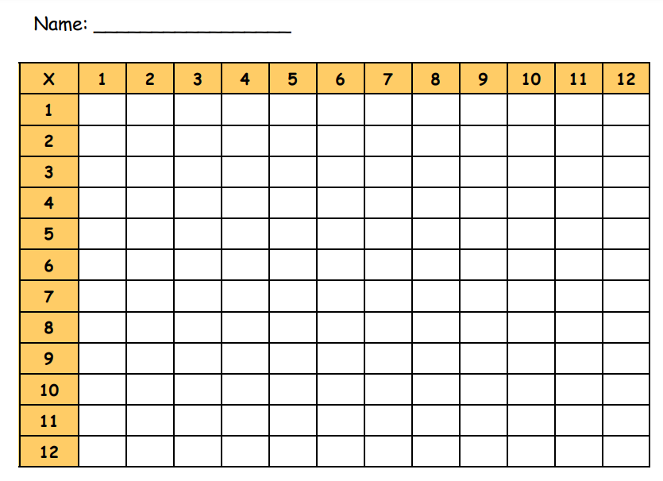
- Flashcards
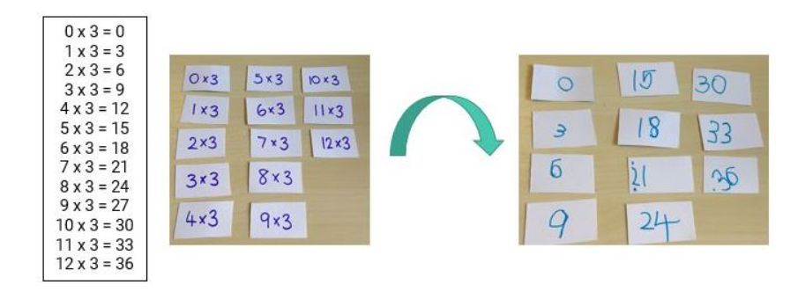

Once these cards have been made, there are lots of options for using with them; first of all, in order to build some memory recall and then, once the child is starting to remember what is on the back, moving to playing with them out of order to further secure the learning. The point here is about taking time to build confidence and develop memory.
- The process needs to be broken up into several steps to maintain motivation and concentration and to build up rehearsal.
- Think about whether to stick to one multiplication table at a time or return to explore a small number of less well remembered facts. It is not a race to learn them all as fast as possible. Focusing on one family or set at a time will allow the child further opportunities to build confidence and develop a more lasting and meaningful memory of the facts.
- Play and create your own games with the cards; whether playing against a partner or children creating their own new rules for using the cards.
- Ask questions such as, “Which facts do you think you already remember?” “Which facts do you think are harder to remember? Why is that?” “How can we remember them?” “How could you use other facts you do remember to help?” This helps children to take more ownership in the learning of facts they see as ‘harder’ to remember.
- Once you feel a multiplication table has been cracked, keep the cards safe and return to them after a break of a week or two. Revisiting tables to keep them fresh will also help to embed the learning.
- Quiz little but often
All classes should use a regular quiz sheet (Thursday / Friday mornings maybe) to test recall and speed – use division facts as well as multiplication. Examples of weekly quiz sheets can be found in X tables Resources folder.
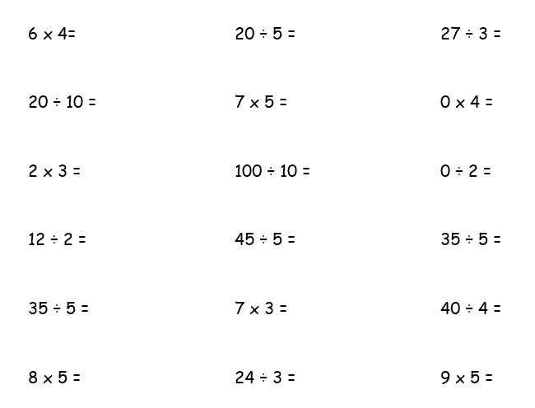

- Times tables taught throughout school
Please see the table below to show which number facts and times tables should be taught and secured in each year group.
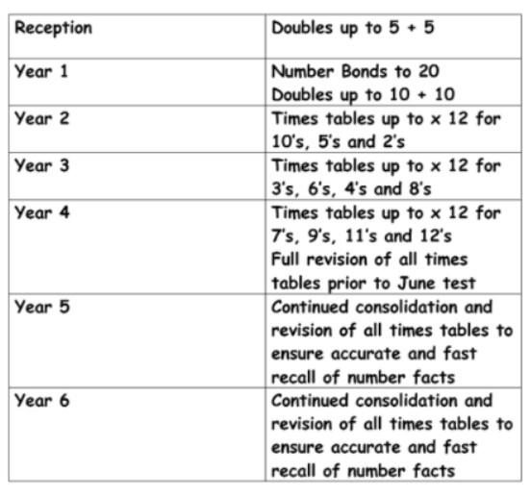

- TT Rockstars and Numbots are available for extra practice. Please encourage the pupils to play these games at home – these online resources should not be used in school as a replacement to teacher facilitated learning.

