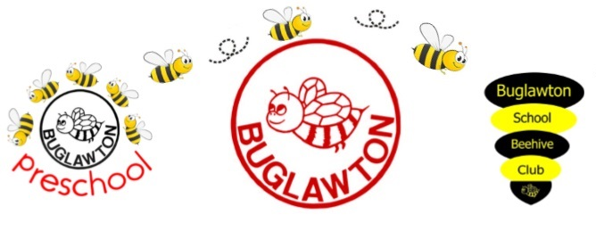
Writing Policy Autumn 2022
INTENT
Rationale:
At Buglawton Primary School our Literacy curriculum is designed to be accessible to all so that every child knows more, remembers more and understands more. At Buglawton, we believe that all children can achieve in writing. We do not hold pre-conceptions about any children’s ability to make progress – it is our aim to help all children reach and exceed their potential. Writing is a fundamental key to all learning and underpins every area of our school curriculum. The ability to understand and use language enables children to explore and interact successfully, communicate their feelings, thoughts and ideas with confidence and develop skills essential for life-long learning. We believe that every child has an equal right to a supportive and stimulating writing environment. At Buglawton, all children are exposed to an inspiring, engaging writing curriculum, where high quality texts provide strong learning platforms for all abilities.

Ambition:
Our intent is to:
- Create a writing curriculum that is progressive and builds on previous learning
- Develop children’s confidence to write for purpose, within a range of text types and contexts
- Teach and use a wide range of high-level vocabulary in writing
- Provide an engaging platform for writing in our school, where children see writing as an enjoyable, creative activity.

IMPLEMENTATION
In order to implement our intent, we have:
- Opportunities for whole school and class enrichment
- A scheme of work that focuses on specific and relevant vocabulary
- Ensured that staff are equipped with the necessary professional development to deliver our curriculum
- A subject leader who monitors teaching and learning to improve standards and outcomes
- A link governor who liaises with the subject leader in order to monitor and improve standards
- A curriculum that meets the needs of all pupils (including SEND and PPG)
- A rigorous process of teaching writing that ensures clear progression
- Termly staff updates in subject development and termly writing moderation with all staff to ensure assessment is accurate across the school
- Daily writing opportunities during Literacy and other subject area
- High level texts are used as a stimulus for each writing unit
- Spellings that are organised into yearly ‘stages’ which children practise through the Spelling Shed app in school and at home
- Comprehensive and progressive ‘assessment’ and ‘writing overview’ documents as well as ‘teaching requirement’ documents to plan appropriate next steps
- Termly independent writing challenges which are assessed and used to inform future learning
- Termly Rising Stars SPaG assessments which are used to inform future learning
- Extra-curricular opportunities to participate in Literacy activities e.g. Comic Club and Creative Writing Club
- Purposeful planned opportunities to write
IMPACT
Through implementing the above
- Children will understand and apply subject specific vocabulary
- Children will achieve age-related expectations
- Children will write confidently and fluently across a range of text types
- Children will make at least good progress from their starting point
- Children will use high level vocabulary to enhance their writing
- Children will spell age appropriate words accurately
- Teaching will address children’s individual learning needs
- Evidence of children’s progress in writing will be seen across all subjects.

